Question 3

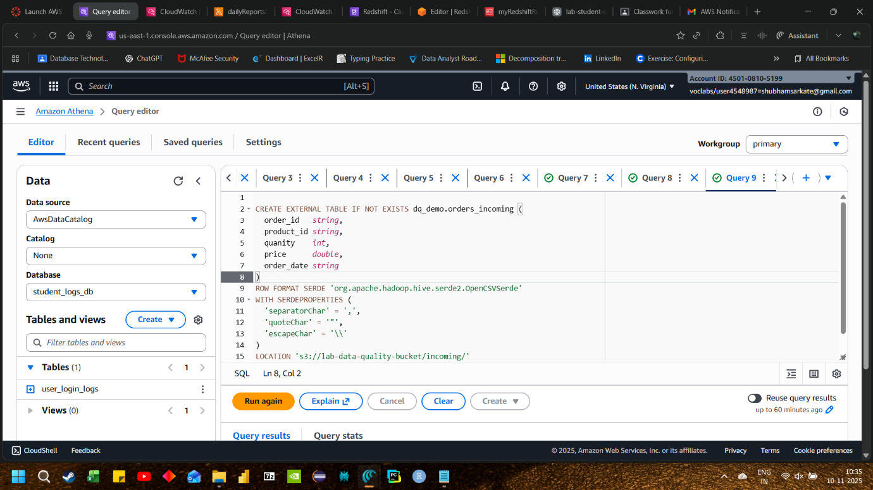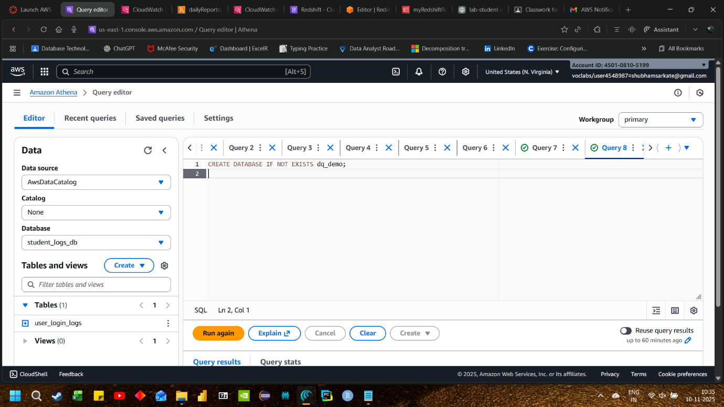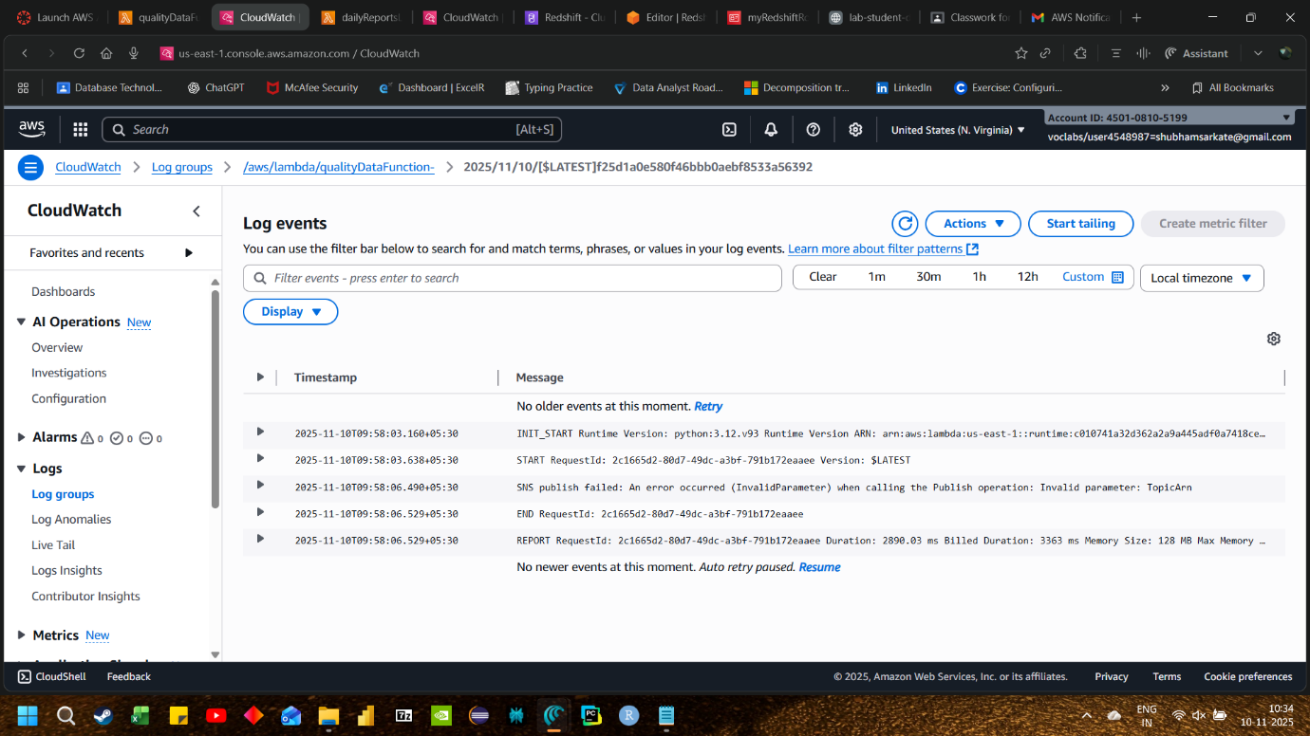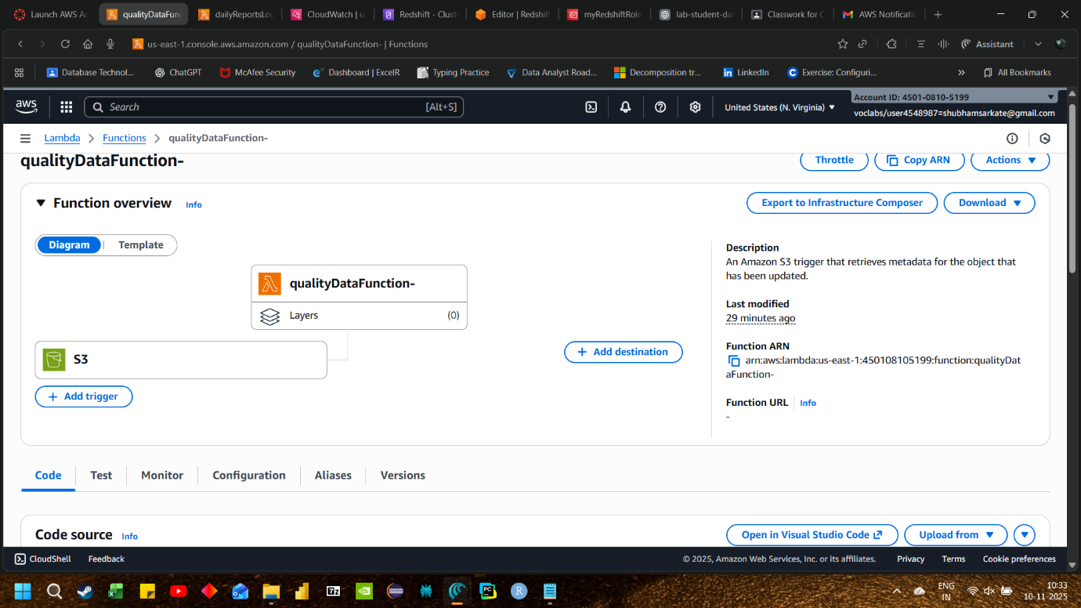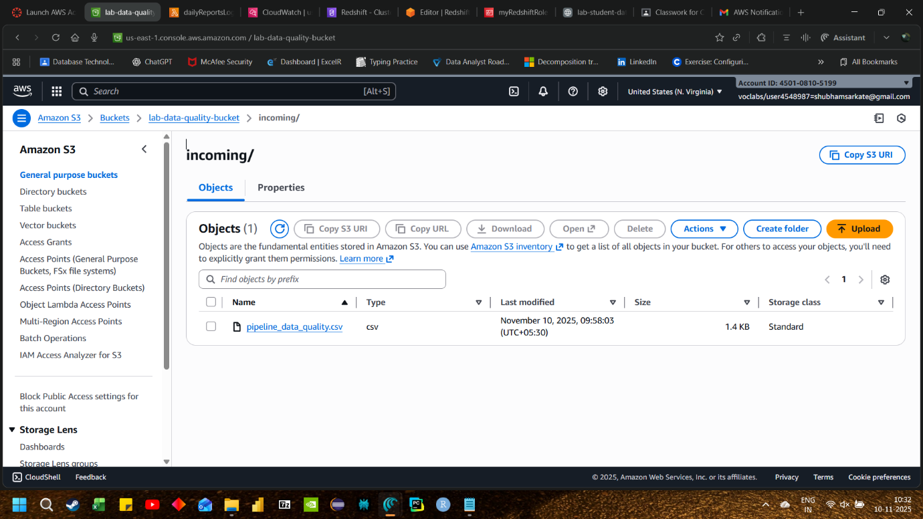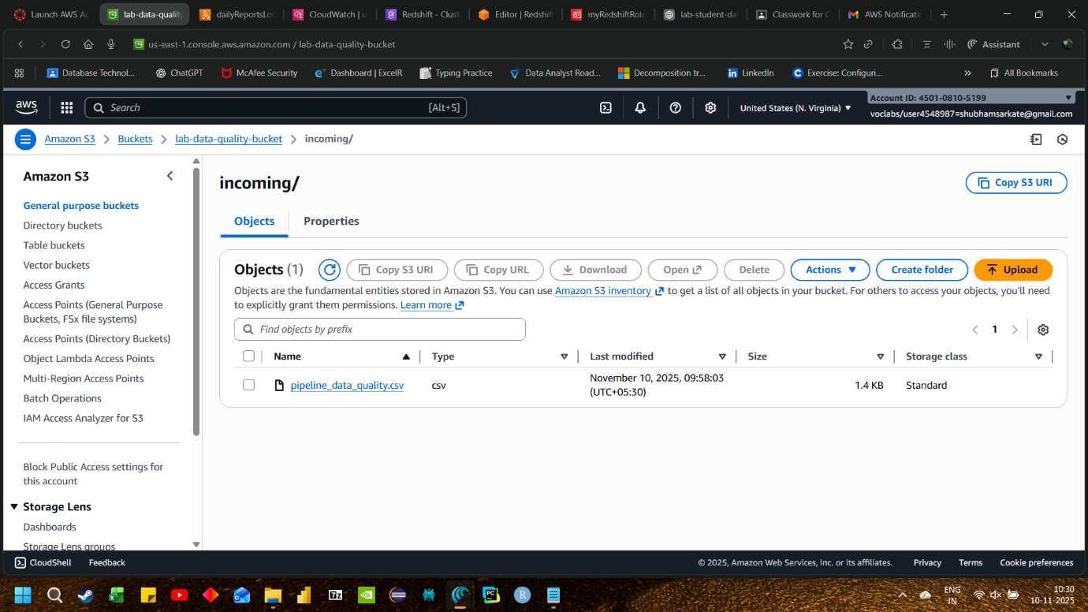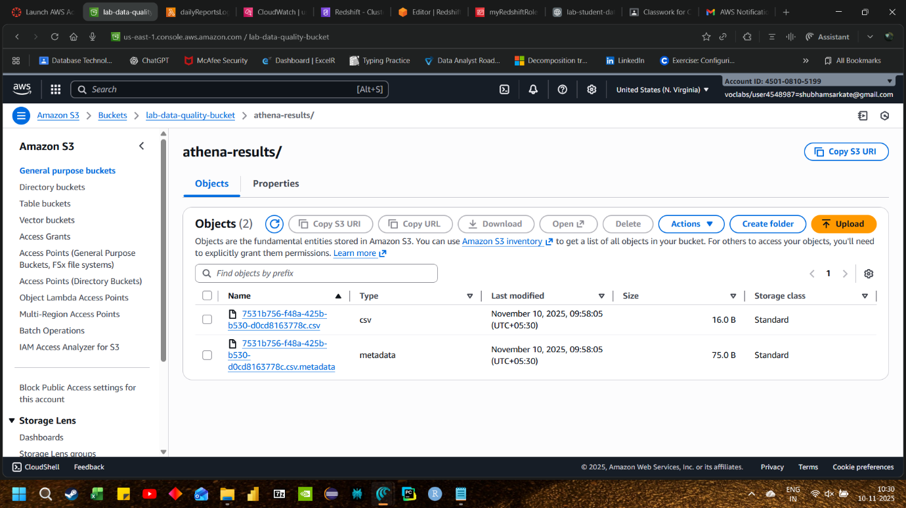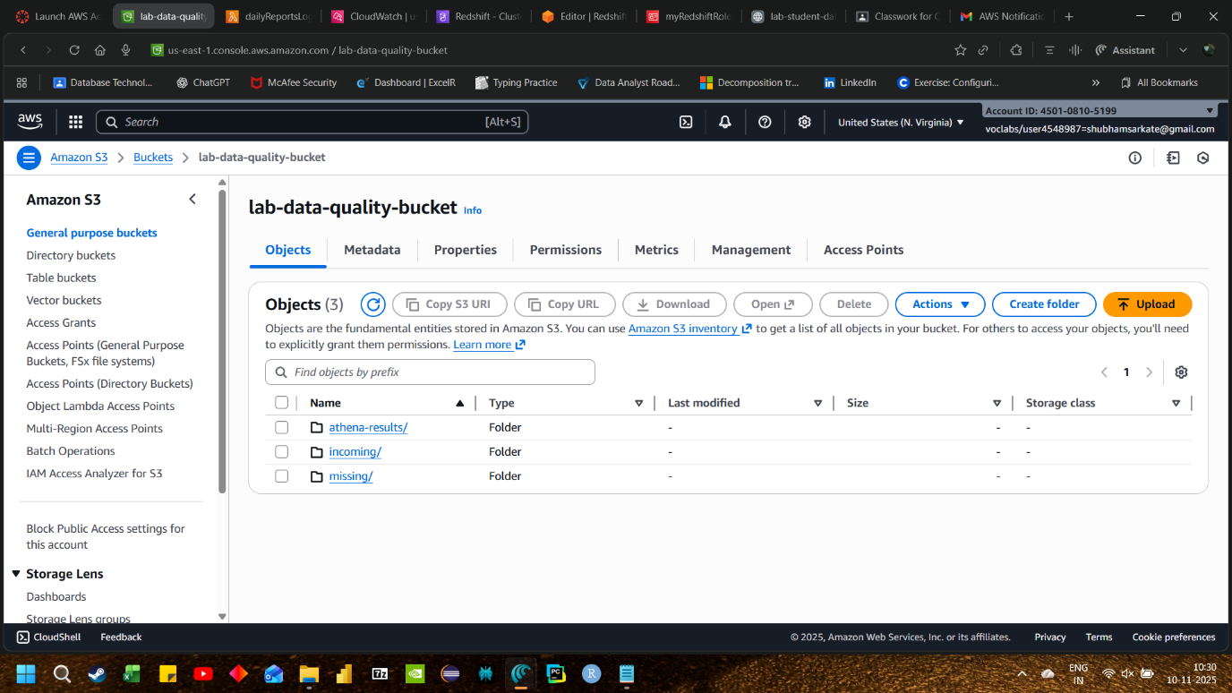

import os
import json
import time
import urllib.parse
import boto3
from botocore.exceptions import ClientError

# ---- EDIT THESE ----
REGION = "us-east-1"
ATHENA_DATABASE = "dq_demo"
ATHENA_WORKGROUP = "primary"
ATHENA_OUTPUT_S3 = "s3://lab-data-quality-bucket/athena-results/"
ATHENA_TABLE = "orders_incoming"
SNS_TOPIC_ARN = "arn:aws:sns:us-east-1:450108105199:data-quality-alerts"
# --------------------

athena = boto3.client("athena", region_name=REGION)
sns = boto3.client("sns", region_name=REGION)

def _start_athena(query: str) -> str:
res = athena.start_query_execution(
QueryString=query,
QueryExecutionContext={"Database": ATHENA_DATABASE},
WorkGroup=ATHENA_WORKGROUP,
ResultConfiguration={"OutputLocation": ATHENA_OUTPUT_S3},
)
return res["QueryExecutionId"]

def _wait_athena(qid: str, timeout=120, poll=2):
t0 = time.time()
while True:
res = athena.get_query_execution(QueryExecutionId=qid)
state = res["QueryExecution"]["Status"]["State"]
if state in ("SUCCEEDED", "FAILED", "CANCELLED"):
return state, res
if time.time() - t0 > timeout:
raise TimeoutError("Athena query timeout")
time.sleep(poll)

def _fetch_single_long(qid: str) -> int:
res = athena.get_query_results(QueryExecutionId=qid, MaxResults=2)
rows = res["ResultSet"]["Rows"]
if len(rows) < 2:
return 0
val = rows[1]["Data"][0].get("VarCharValue", "0")
try:
return int(float(val))
except ValueError:
return 0

def _publish_alert(subject: str, message: str):
try:
sns.publish(TopicArn=SNS_TOPIC_ARN, Subject=subject[:100], Message=message)
except ClientError as e:
print(f"SNS publish failed: {e}")

def lambda_handler(event, context):
alerts = []
for rec in event.get("Records", []):
if rec.get("eventSource") != "aws:s3":
continue
bucket = rec["s3"]["bucket"]["name"]
key = urllib.parse.unquote_plus(rec["s3"]["object"]["key"])

s3_uri_like = f"s3://{bucket}/{key}"
dq_query = f"""
SELECT COUNT(*) AS bad_count
FROM {ATHENA_TABLE}
WHERE (order_id IS NULL OR trim(order_id) = '' OR price < 0)
AND "$path" = '{s3_uri_like}'
"""
try:
qid = _start_athena(dq_query)
state, _ = _wait_athena(qid)
if state != "SUCCEEDED":
raise RuntimeError(f"Athena query {qid} ended in state {state}")
bad_count = _fetch_single_long(qid)
except Exception as e:
_publish_alert(
subject="Data Quality Check FAILED",
message=json.dumps({"bucket": bucket, "key": key, "error": str(e)}, indent=2)
)
raise

if bad_count > 0:
msg = {
"bucket": bucket,
"key": key,
"bad_count": bad_count,
"rule": "order_id missing/blank OR price < 0",
}
_publish_alert(
subject="Data Quality Alert: Bad records detected",
message=json.dumps(msg, indent=2)
)
alerts.append(msg)

return {"alerts_sent": alerts}

